1. Open start.spring.io

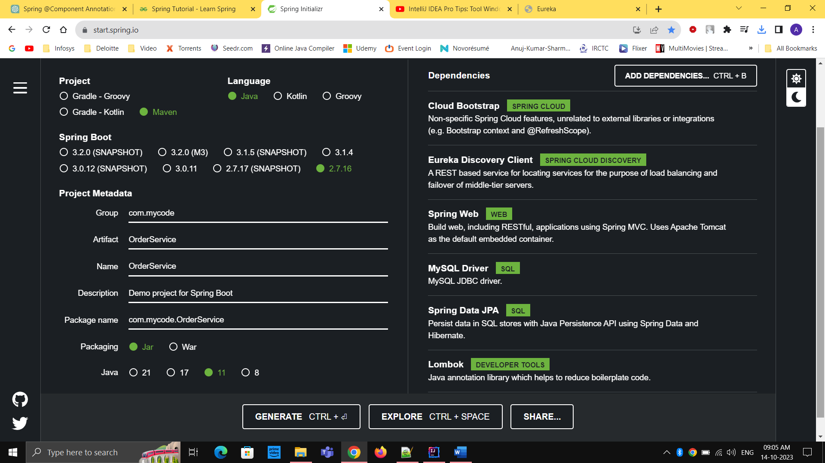

1. Open application.yaml

server:  
 port: 8082  
  
spring:  
 datasource:  
 url: jdbc:mysql://${DB_HOST:localhost}:3306/orderdb  
 username: root  
 password: root  
 driverClassName: com.mysql.cj.jdbc.Driver  
 jpa:  
 database-platform: org.hibernate.dialect.MySQL57InnoDBDialect  
 hibernate:  
 ddl-auto: update  
  
 application:  
 name: ORDER-SERVICE  
  
eureka:  
 instance:  
 prefer-ip-address: true  
 client:  
 fetch-registry: true  
 register-with-eureka: true  
 service-url:  
 defaultZone: ${EUREKA_SERVER_ADDRESS:http://localhost:8761/eureka}

1. Create Order.java inside entity package

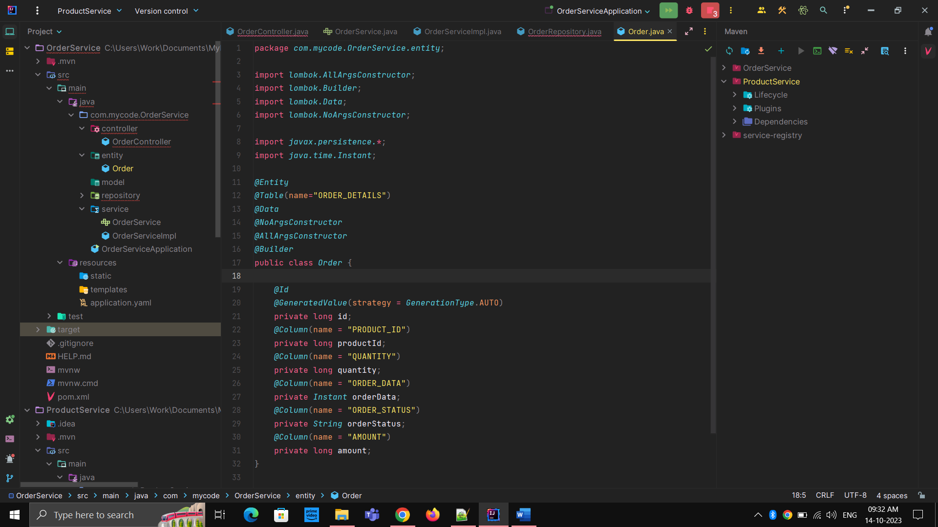

1. Create OrderRequest.java inside Model package

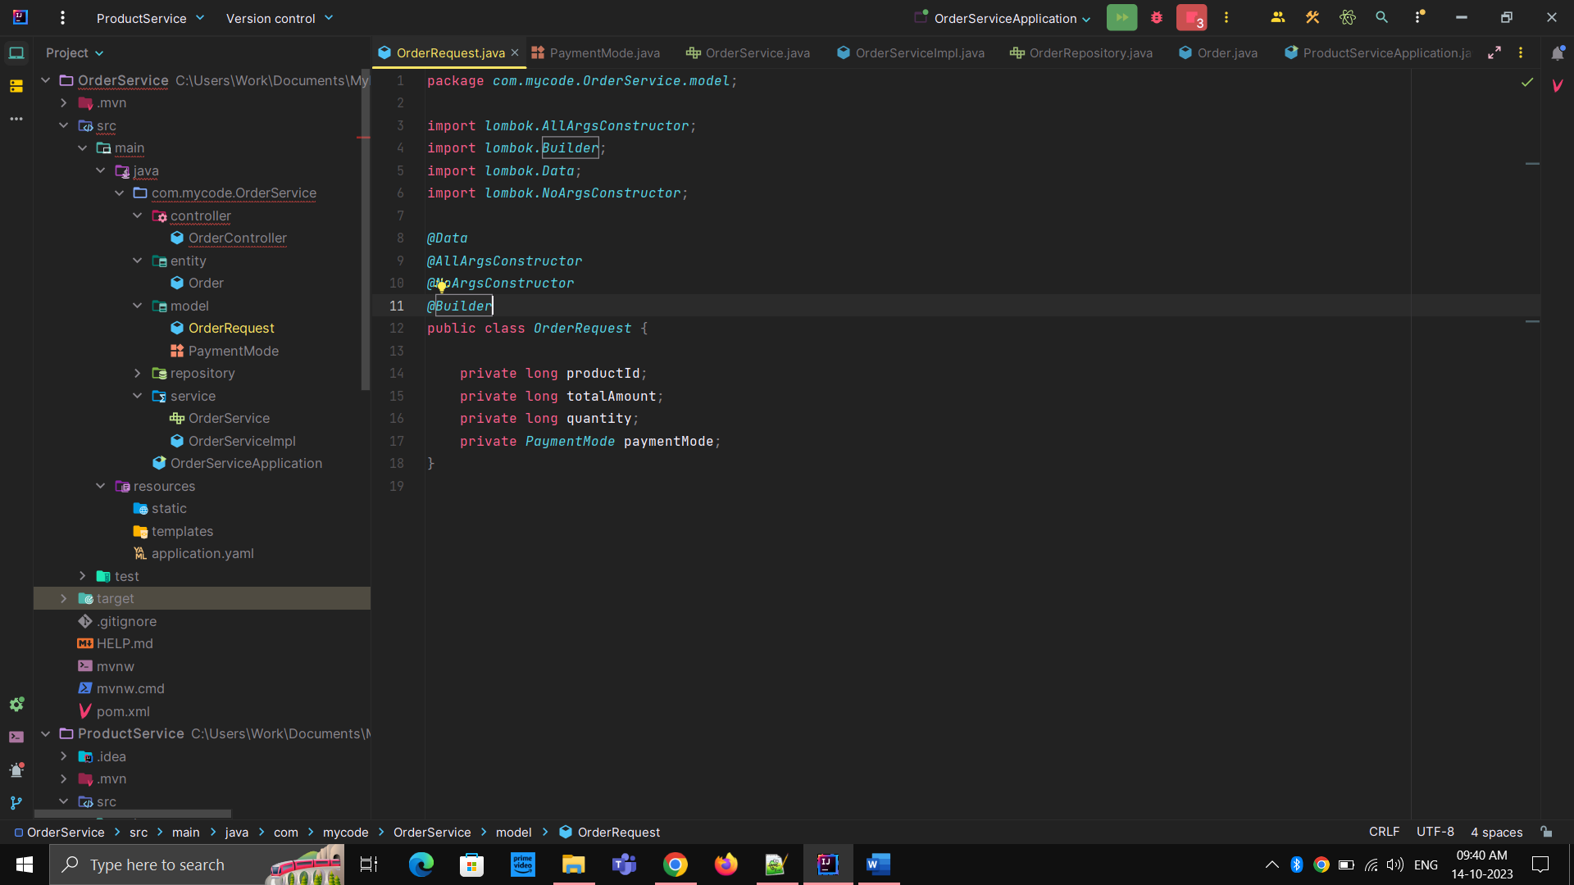

1. Create an ENUM PaymentMode inside model package

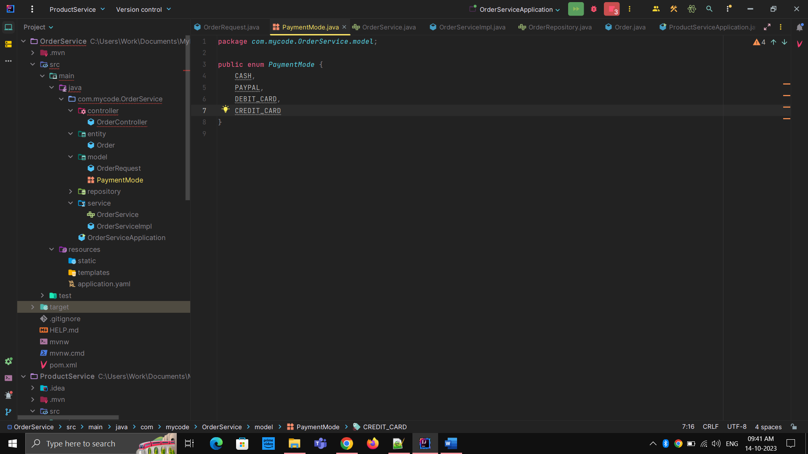

1. Create OrderController.java inside the controller package

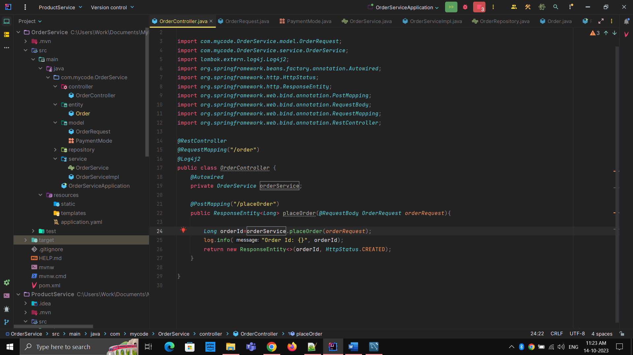

1. Create OrderServiceImpl.java and write the business logic

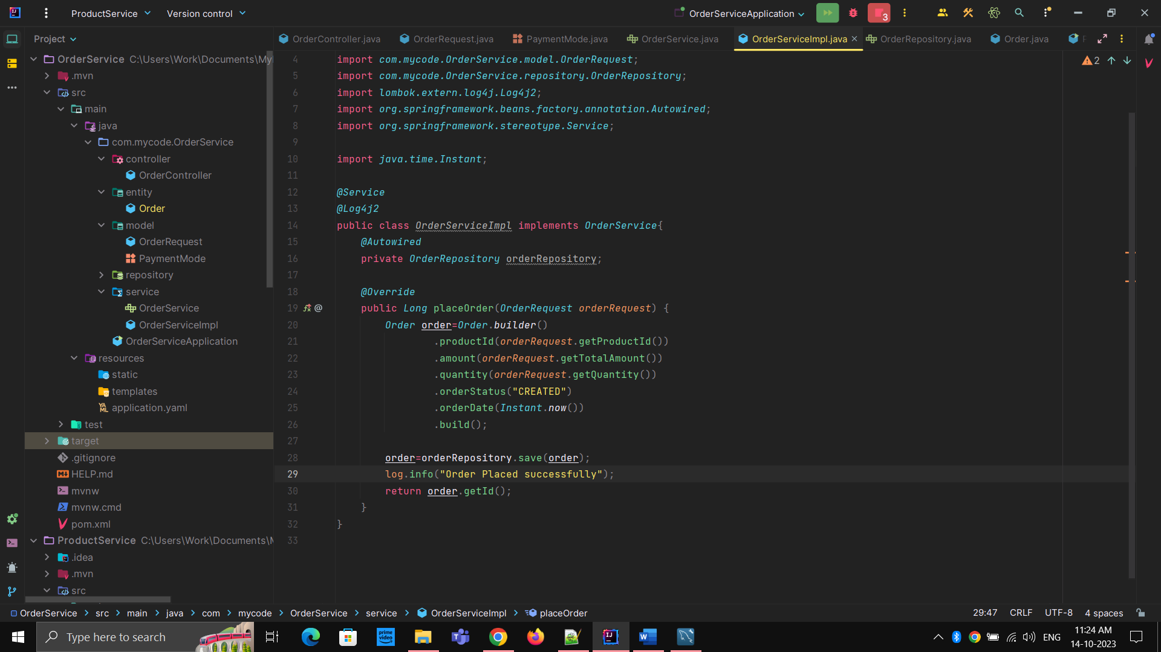

1. Run the application
2. Open the PostMan and hit the endpoint
3. <http://localhost:8082/order/placeOrder>

{

    "productId" : 1,

    "totalAmount" : 64000,

    "quantity" : 1,

    "paymentMode" : "CASH"

}